What is a CRO (Cathode Ray Oscilloscope) & Its Working
The CRO stands for a cathode ray oscilloscope. It is typically divided into four sections which are display, vertical controllers, horizontal controllers, and Triggers. Most of the oscilloscopes are used the probes and they are used for the input of any instrument. We can analyze the waveform by plotting amplitude along with the x-axis and y-axis. The applications of CRO are mainly involved in the radio, TV receivers, also in laboratory work involving research and design. In modern electronics, the CRO plays an important role in the electronic circuits.
What is a CRO?
The cathode ray oscilloscope is an electronic test instrument, it is used to obtain waveforms when the different input signals are given. In the early days, it is called as an Oscillograph. The oscilloscope observes the changes in the electrical signals over time, thus the voltage and time describe a shape and it is continuously graphed beside a scale. By seeing the waveform, we can analyze some properties like amplitude, frequency, rise time, distortion, time interval, and etc.
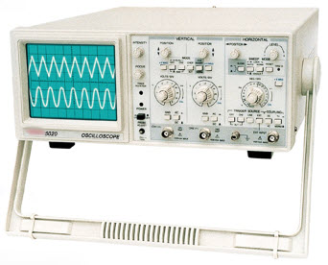
Cathode Ray Oscilloscope
Block Diagram of CRO
The following block diagram shows the general-purpose CRO contraction. The CRO recruits the cathode ray tube and acts as a heart of the oscilloscope. In an oscilloscope, the CRT produces the electron beam which is accelerated to a high velocity and brings to the focal point on a fluorescent screen.
Thus, the screen produces a visible spot where the electron beam strikes with it. By detecting the beam above the screen in reply to the electrical signal, the electrons can act as an electrical pencil of light which produces a light where it strikes.
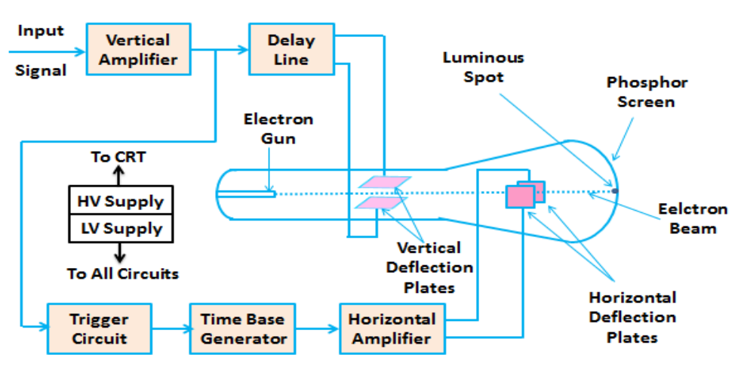
CRO Block Diagram
To complete this task we need various electrical signals and voltages. This provides the power supply circuit of the oscilloscope. Here we will use high voltage and low voltage. The low voltage is used for the heater of the electron gun to generate the electron beam. A high voltage is required for the cathode ray tube to speed up the beam. The normal voltage supply is necessary for other control units of the oscilloscope.
The horizontal and vertical plates are placed between the electron gun and the screen, thus it can detect the beam according to the input signal. Just before detecting the electron beam on the screen in the horizontal direction which is in X-axis a constant time-dependent rate, a time base generator is given by the oscillator. The signals are passed from the vertical deflection plate through the vertical amplifier. Thus, it can amplify the signal to a level that will be provided the deflection of the electron beam.
If the electron beam is detected in the X-axis and the Y-axis a trigger circuit is given for synchronizing these two types of detections. Hence the horizontal deflection starts at the same point as the input signal.
Working Principle
The CRO working principle depends on the electron ray movement because of the electrostatic force. Once an electron ray hits a phosphor face, then it makes a bright spot on it. A Cathode Ray Oscilloscope applies the electrostatic energy on the electron ray from two vertical ways. The spot on the phosphor monitor turns due to the effect of these two electrostatic forces which are mutually perpendicular. It moves to make the necessary waveform of the input signal.
Construction of Cathode Ray Oscilloscope
The construction of CRO includes the following.
- Cathode Ray Tube
- Electronic Gun Assembly
- Deflecting Plate
- Fluorescent Screen For CRT
- Glass Envelop

Cathode Ray Tube
The CRO is the vacuum tube and the main function of this device is to change the signal from electrical to visual. This tube includes the electron gun as well as the electrostatic deflection plates. The main function of this electron gun is used to generate a focused electronic ray that speeds up to high frequency.
The vertical deflection plate will turn the ray up & down whereas the horizontal ray moved the electrons beams from the left side to the right side. These actions are autonomous from each other and thus the ray may be located anyplace on the monitor.
Electronic Gun Assembly
The main function of the electron gun is to emit the electrons to form them into a ray. This gun mainly includes a heater, a grid, cathode, and anodes like accelerating, pre-accelerating & focusing. At the cathode end, the strontium & barium layers are deposited to obtain the high electrons emission of electrons at the moderate temperature, the layers of barium, and are deposited at the end of the cathode.
Once the electrons are generated from the cathode grid, then it flows throughout the control grid that is generally a nickel cylinder through a centrally situated co-axial by the axis of CRT. So, it controls the strength of the generated electrons from the cathode.
When electrons flow throughout the control grid then it accelerates with the help of a high positive potential which is applied to the pre-accelerating or accelerating nodes. The electron ray is concentrated on electrodes to flow throughout the deflection plates like horizontal and vertical & supplies on to the fluorescent lamp.
The anodes like accelerating & pre-accelerating are connected to 1500v & the focusing electrode can be connected to 500v. The electron ray can be focused on using two techniques like Electrostatic & Electromagnetic focusing. Here, a cathode ray oscilloscope utilizes an electrostatic focusing tube.
Deflecting Plate
Once the electron ray leaves the electron gun then this ray will pass throughout the two sets of the deflecting plate. This set will generate the vertical deflection that is known as Y plate’s otherwise vertical deflecting plate. The set of the plate is used for a horizontal deflection which is known as X plate’s otherwise horizontal deflection.
Fluorescent Screen of CRT
In the CRT, the front face is known as the faceplate, For the CRT screen, it is flat and its size is about 100mm×100mm. The CRT screen is somewhat bent for bigger displays and the formation of faceplate can be done by pressing the molten glass into a form & after that heating it.
The inner face of the faceplate is covered by using phosphor crystal to change the energy from electrical to light. Once an electronics ray hits phosphor crystal, the energy level can be enhanced & thus light is generated throughout phosphorous crystallization, so this occurrence is known as fluorescence.
Glass Envelope
It is an extremely evacuated conical form of construction. The inside faces of the CRT among the neck as well as the display are covered through the aquadag. This is a conducting material that acts like a high-voltage electrode. The surface of the coating is connected electrically toward the accelerating anode to help the electron to be the center.
Electrical Quantities Measurements
Electrical quantities measurements by using CRO can be done like amplitude, time period and frequency.
- Measurement of Amplitude
- Measurement of Time Period
- Measurement of Frequency
Measurement of Amplitude
The displays like CRO is used to exhibit the voltage signal like a time function on its display. The amplitude of this signal is stable; however, we can change the number of partitions that cover up the voltage signal within vertical way by changing volt/division button on top of the CRO board. So, we will acquire the signal’s amplitude, which is there on the CRO screen with the help of the below formula.
A = j * nv
Where,
‘A’ is the amplitude
‘j’ is the volt/division value
‘nv’ is the no. of partitions that cover up the signal within a vertical way.
Measurement of Time Period
CRO displays the voltage signal as a function of time on its screen. The Time period of that periodic voltage signal is constant, but we can vary the number of divisions that cover one complete cycle of the voltage signal in the horizontal direction by varying the time/division knob on the CRO panel.
Therefore, we will get the Time period of the signal, which is present on the screen of CRO by using the following formula.
T = k * nh
Where,
‘T’ is the Time period
‘j’ is the time/division value
‘nv’ is the number of partitions that cover up one whole cycle of the periodic signal within the horizontal way.
Measurement of Frequency
On the CRO screen, the measurement of tile & frequency can be done very simply through the horizontal scale. If you want to make sure accuracy while measuring a frequency, then it assists to enhance the area of the signal on your CRO display so that we can more simply convert the waveform.
Initially, the time can be measured with the help of the horizontal scale on the CRO & counting the number of flat partitions from one finish of the signal to the other wherever it crosses the flat line. After that, we can develop the number of flat partitions through the time or division to discover the time period of the signal. Mathematically the measurement of the frequency can be signified as frequency = 1/period.
f = 1/T
Basic Controls of CRO
The basic controls of CRO mainly include position, brightness, focus, astigmatism, blanking & calibration.

Position
In the oscilloscope, the position control knob is mainly used for position control of the intense spot from the left side to the right side. By regulating the knob, one can simply control the spot from left side to the right side.
Brightness
The ray’s brightness mainly depends on the intensity of the electron. The control grids are accountable for the electron intensity within the electron ray. So, the grid voltage can be controlled by adjusting the electron ray brightness.
Focus
The focus control can be achieved by regulating the applied voltage toward the center anode of the CRO. The middle & other anodes in the region of it can form the electrostatic lens. Therefore, the main length of the lens can be changed by controlling the voltage across the center anode.
Astigmatism
In CRO, this is an extra focusing control & it is analogous toward astigmatism within optical lenses. A ray is focused in the middle of the monitor would be defocused on the screen edges as the electron paths lengths are dissimilar for the center & the edges.
Blanking Circuit
The time base generator present in the oscilloscope generated the blanking voltage.
Calibration Circuit
An oscillator is necessary for the purpose of calibration within an oscilloscope. However, the oscillator which is used should generate a square waveform for preset voltage.
Applications
- The CRO’s are used in huge applications like radio stations for observing the transmitting & receiving the properties of the signal.
- The CRO is used to measure the voltage, current, frequency, inductance, admittance, resistance, and power factor.
- This device is also used to check the AM and FM circuits characteristics
- This device is used to monitor the signal properties as well as characteristics and also controls the analog signals.
- The CRO is used through the resonance circuit to view the shape of the signal, bandwidth, etc.
- The shape of voltage and current waveform can be observed by CRO which helps to take the necessary decision in a radio station or communication station.
- It is used in laboratories for the purpose of research. Once researchers design a new circuit, then they use CRO to verify the waveforms of voltage and current of every element of the circuit.
- Used for comparing phase & frequency
- It is used in TV, Radar, and analysis of engine pressure
- To check the reactions of nervous and heartbeat.
- In the hysteresis loop, it is used to find BH curves
- Transistor curves can be traced.
Advantages
The advantages of CRO include the following.
- Cost and Timeline
- Training requirements
- Consistency & quality
- Time efficiency
- Expertise & experience
- Capacity for problem-solving
- Hassle-free
- Assurance for regulatory compliance
- Voltage measurement
- Current measurement
- Examination of waveform
- Measurement of phase and frequency
Disadvantages
The disadvantages of CRO include the following.
- These oscilloscopes are expensive as compared with other measuring devices like multimeters.
- They are complicated to repair once it gets damaged.
- These devices need complete isolation
- These are huge, heavy and uses more power
- A lot of control terminals which is not so easy to understand at one instance But for easy of use, multiple channel capture and screen and waveform clarity one could go for Digital Storage Oscilloscope.
Uses of CRO
In the laboratory, the CRO can be used as
- It can display different types of waveforms
- It can measure the short time interval
- In voltmeter, it can measure the potential difference.

What is Digital Storage Oscilloscope : Working & Its Applications
In 1897, Karl Ferdinand Brawn invented an oscilloscope. We know about the cathode ray oscilloscope which is used for the display and analysis of different types of waveforms of electronic signals in the electronics and electrical circuits. The DSO is also one type of oscilloscope, used to display the waveform, but the difference between CRO and DSO is that in DSO, the digital signal is converted into analog and that analog signal will be displayed on the screen of the digital storage oscilloscope. In the conventional CRO, there is no procedure for the storage of the waveform but in DSO, there is a digital memory that is going to store the digital copy of the waveform. A brief explanation about DSO is explained below.

What is Digital Storage Oscilloscope?
Definition: The digital storage oscilloscope is an instrument which gives the storage of a digital waveform or the digital copy of the waveform. It allows us to store the signal or the waveform in the digital format, and in the digital memory also it allows us to do the digital signal processing techniques over that signal. The maximum frequency measured on the digital signal oscilloscope depends upon two things they are: sampling rate of the scope and the nature of the converter. The traces in DSO are bright, highly defined, and displayed within seconds.

Block Diagram of Digital Storage Oscilloscope
The block diagram of the digital storage oscilloscope consists of an amplifier, digitizer, memory, analyzer circuitry. Waveform reconstruction, vertical plates, horizontal plates, cathode ray tube (CRT), horizontal amplifier, time base circuitry, trigger, and clock. The block diagram of the digital storage oscilloscope is shown in the below figure.
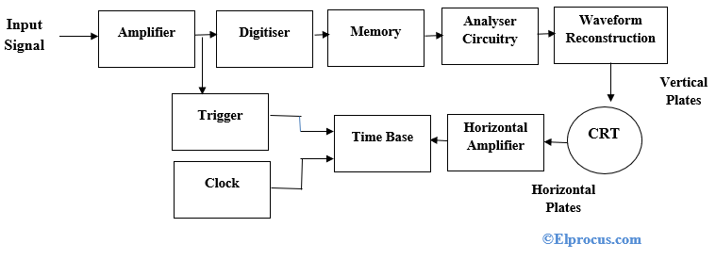Digital Storage Oscilloscope Block Diagram
As seen in the above figure, at first digital storage oscilloscope digitizes the analog input signal, then the analog input signal is amplified by amplifier if it has any weak signal. After amplification, the signal is digitized by the digitizer and that digitized signal stores in memory. The analyzer circuit process the digital signal after that the waveform is reconstructed (again the digital signal is converted into an analog form) and then that signal is applied to vertical plates of the cathode ray tube (CRT).
The cathode ray tube has two inputs they are vertical input and horizontal input. The vertical input signal is the ‘Y’ axis and the horizontal input signal is the ‘X’ axis. The time base circuit is triggered by the trigger and clock input signal, so it is going to generate the time base signal which is a ramp signal. Then the ramp signal is amplified by the horizontal amplifier, and this horizontal amplifier will provide input to the horizontal plate. On the CRT screen, we will get the waveform of the input signal versus time.
The digitizing occurs by taking a sample of the input waveform at periodic intervals. At the periodic time interval means, when half of the time cycle is completed then we are taking the samples of the signal. The process of digitizing or sampling should follow the sampling theorem. The sampling theorem says that the rate at which the samples are taken should be greater than twice the highest frequency present in the input signal. When the analog signal is not properly converted into digital then there occurs an aliasing effect.

When the analog signal is properly converted into digital then the resolution of the A/D converter will be decreased. When the input signals stored in analog store registers can be read out at a much slower rate by the A/D converter, then the digital output of the A/D converter stored in the digital store, and it allows operation up to 100 mega samples per second. This is the working principle of a digital storage oscilloscope.

DSO Operation Modes
The digital storage oscilloscope works in three modes of operations they are roll mode, store mode, and hold or save mode.
Roll Mode: In roll mode, very fast varying signals are displayed on the display screen.
Store Mode: In the store mode the signals stores in memory.
Hold or Save Mode: In hold or save mode, some part of the signal will hold for some time and then they will be stored in memory.
These are the three modes of digital storage oscilloscope operation.

Waveform Reconstruction
There are two types of waveform reconstructions they are linear interpolation and sinusoidal interpolation.
Linear Interpolation: In linear interpolation, the dots are joined by a straight line.
Sinusoidal Interpolation: In sinusoidal interpolation, the dots are joined by a sine wave.
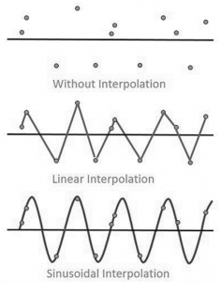
Waveform Reconstruction of Digital Storage Oscilloscope
Advantages:-
1. Allows for automation.
2. In this, slow traces like the temperature variation across a day can be recorded
3. With colour Bigger and brighter display, to distinguish multiple traces
4. peak detection
Disadvantage:- Digital Oscilloscope is the limited refresh rate of the screen

Difference Between Digital Storage Oscilloscope and Conventional Storage Oscilloscope
The difference between DSO and the conventional storage oscilloscope or analog storage oscilloscope (ASO) is shown in the below table.
S.NO | Digital Storage Oscilloscope | Conventional Storage Oscilloscope
1 | The digital storage oscilloscope collects data always | After triggering only, the conventional storage oscilloscope collects data
2 | The cost of the tube is cheap | The cost of the tube is costlier
3 | For higher frequency signals the DSO produce bright images | For higher frequency signals the ASO cannot produce bright images
4 | The resolution is higher in digital storage oscilloscope | The resolution is lower in conventional storage oscilloscope
5 | In DSO an operating speed is less | In ASO an operating speed is more

